Assignment Sheet – 4
Name – Sayak Sen
Enrollment No – 2023CSB047
Assignment – 8
Table Creation :
CREATE TABLE Customer (
cust_id INT PRIMARY KEY CHECK (cust_id BETWEEN 100 AND 10000),
cust_name VARCHAR(100) NOT NULL,
annual_revenue DECIMAL(12, 2),
cust_type VARCHAR(20) CHECK (
cust_type IN (
'MANUFACTURER',
'WHOLESALER',
'RETAILER'
)
)
);

-- TRUCK TABLE
CREATE TABLE Truck (
truck_no INT PRIMARY KEY,
driver_name VARCHAR(100) NOT NULL
);

-- CITY TABLE
CREATE TABLE City (
city_name VARCHAR(100) PRIMARY KEY,
population INT
);

-- SHIPMENT TABLE
CREATE TABLE Shipment (
shipment_no INT PRIMARY KEY,
cust_id INT,
weight DECIMAL(10, 2) CHECK (weight < 1000),
truck_no INT,
destination VARCHAR(100),
ship_date DATE,
FOREIGN KEY (cust_id) REFERENCES Customer (cust_id) ON DELETE CASCADE,
FOREIGN KEY (truck_no) REFERENCES Truck (truck_no) ON DELETE SET NULL,
FOREIGN KEY (destination) REFERENCES City (city_name)
);

Customer Table :
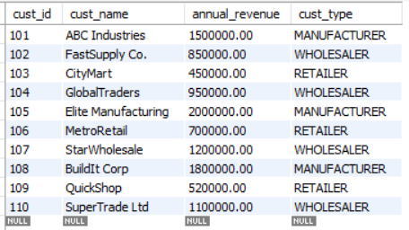

Shipment Table :
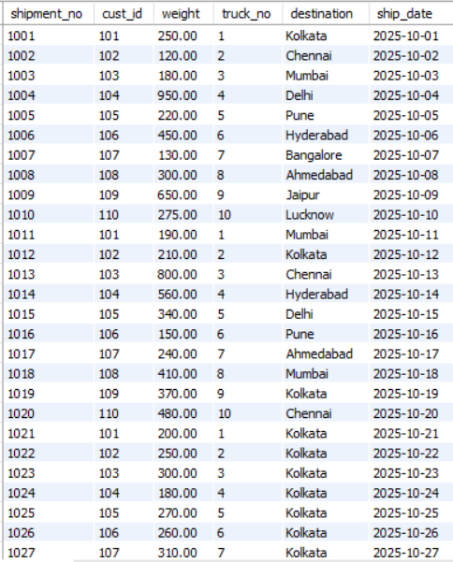
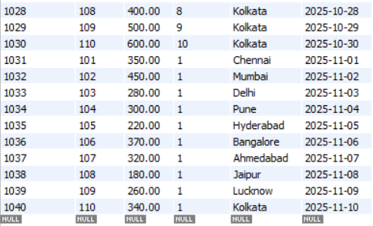
City Table :
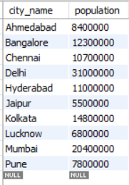
Truck Table :
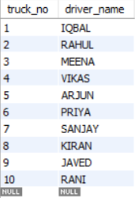
- Give names of customer who have sent packages (shipments) to Kolkata, Chennai and Munbai.
select cust_name
from customer, shipment
where customer.cust_id = shipment.cust_id and destination in ('Kolkata','Chennai','Mumbai');

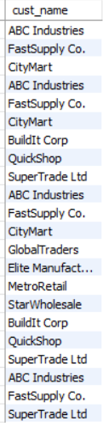
2.List the names of the driver who have delivered shipments weighing over 200 pounds.
select distinct driver_name
from truck, shipment
where truck.truck_no = shipment.truck_no and weight > 200;

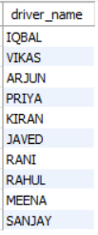
3.Retrieve the maximum and minimum weights of the shipments. Rename the output as Max_Weight and Min_Weight respectively.
select max(weight) as Max_Weight, min(weight) as Min_Weight
from shipment;
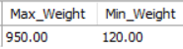
4. For each customer, what is the average weight of package sent by the customer?
select cust_id, avg(weight) as Avg_Weight
from shipment
group by cust_id;

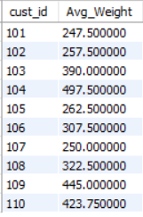
5. List the names and populations of cities that have received a shipment weighing over 100 pounds.
select DISTINCT city_name,population
from city, shipment
where city.city_name = shipment.destination and weight > 100;

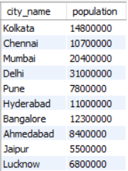

6. List cities that have received shipments from every customer.
select city_name
from shipment, city
where shipment.destination = city.city_name
group by city_name
having count(distinct cust_id) = ( select count(*) from customer );

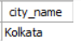
7. For each city, what is the maximum weight of a package sent to that city?
select city_name ,max(weight) as Max_Weight
from city,shipment where city_name = destination
group by city_name;
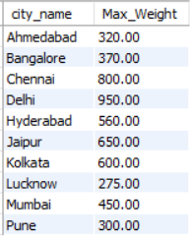
8. List the name and annual revenue of customers whose shipments have been delivered by truck driver ‘IQBAL’.
select cust_name,annual_revenue
from customer, shipment,truck
where customer.cust_id = shipment.cust_id and shipment.truck_no = truck.truck_no and driver_name = 'IQBAL';

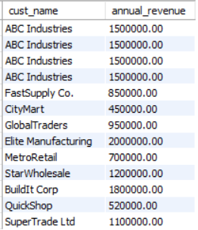
9. List drivers who have delivered shipments to every city.
select driver_name
from truck,shipment
where shipment.truck_no = truck.truck_no
group by truck.truck_no
having count(distinct destination) = (select count(*) from city);

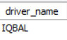
10. For each city, with population over 1 million, what is the minimum weight of a package sent to that city.
select city_name,min(weight) as MIN_Weight
from city,shipment
where city_name = destination
and population > 1000000
group by city_name;

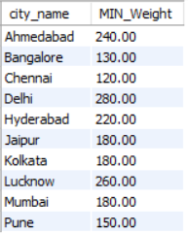

Assignment – 9
Table Creation :
CREATE TABLE DEPT (
DEPTNO CHAR(4) PRIMARY KEY CHECK (DEPTNO LIKE 'D%'),
DNAME VARCHAR(20) CHECK (DNAME IN ('Accounting', 'Sales', 'Research', 'Operations')),
LOC VARCHAR(20)
);

CREATE TABLE EMP (
EMPNO INT PRIMARY KEY CHECK (EMPNO BETWEEN 7000 AND 8000),
ENAME VARCHAR(10) NOT NULL,
JOB VARCHAR(10) CHECK (JOB IN ('Clerk','Salesman','Manager','Analyst','President')),
MGR INT,
HIREDATE DATE,
SAL DECIMAL(10,2),
COMM DECIMAL(10,2) DEFAULT 0 CHECK (COMM < 1500),
DEPTNO CHAR(4),
FOREIGN KEY (DEPTNO) REFERENCES DEPT(DEPTNO),
FOREIGN KEY (MGR) REFERENCES EMP(EMPNO)
);
Employee Table
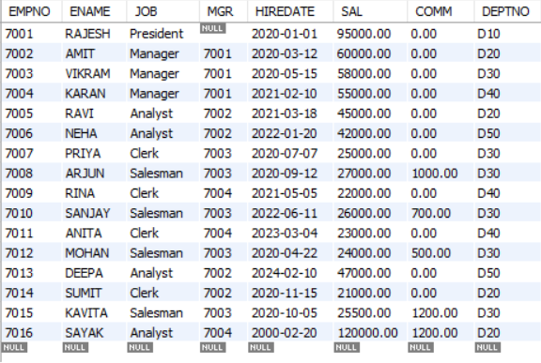

Department Table
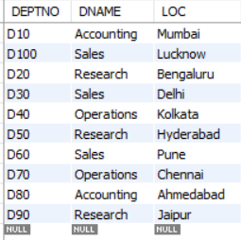
- Display the difference between highest and lowest salary of each department in descending order. Label the column as “Difference”.
select dept.DNAME, max(SAL) - min(SAL) as Difference
from emp,dept
where emp.deptno = dept.deptno
group by dept.DEPTNO
order by Difference desc;

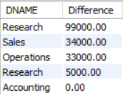
2.List all the employees’ employee number and name along with their immediate managers’ employee number and name.

select A.EMPNO as employee_id, A.ENAME as employee_name, B.EMPNO as manager_id, B.ENAME as manager_name
from EMP A, EMP B
where A.MGR = B.EMPNO;

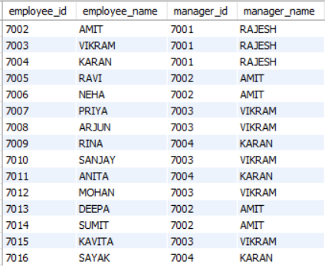
3.Create a query that will display the total number of employees and the total number of employees who were hired only in 2020. Give the column headings as “TOTAL” and “TOTAL_2020” respectively.
select TOTAL,TOTAL_2000
from
(select count(*) as TOTAL from EMP ) as tb1,
(select count(*) as TOTAL_2000 from EMP where HIREDATE between '2000-01-01' and '2000-12-31') as tb2;

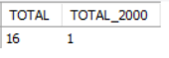

4. Display the manager number and the salary of the lowest paid employee under that
manager. Exclude anyone whose manager is not known. Exclude any group where the
minimum salaryis less than 1000. Sort the output in descending order of salary.
select MGR as manager_id,min(SAL) as min_salary
from emp
group by MGR
having MGR is not NULL and min(SAL) > 1000
order by min_salary desc;

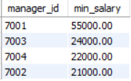
5. Assume that there are some departments where no employee is assigned. Now, write
a query to display the department name, location name, number of employees, and the
average salary for all the employees in that department. Label the columns as
“DNAME”, “LOCATION”, “NUMBER OF PEOPLE”, and “AVERAGE SALARY”respectively. Round the averge salary to two decimal places. The outcome of the
query must include the details of the departments where no employee is assigned and
in that case the “AVERAGE SALARY” for that department is to be displayed as 0 (zero).
select DNAME,loc as LOCATION,count(EMPNO) as "NUMBER OF PEOPLE", ROUND(avg(SAL),2) as "AVERAGE SALARY"
from emp,dept
where emp.deptno = dept.deptno
group by DNAME,LOC
union
select DNAME,loc as LOCATION,count(EMPNO) as "NUMBER OF PEOPLE", ROUND(0,2) as "AVERAGE SALARY"
from emp,dept
where dept.deptno not in (select distinct(deptno) from EMP)
group by DNAME,LOC;

